
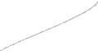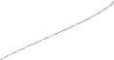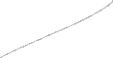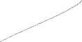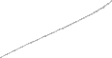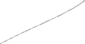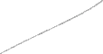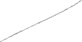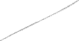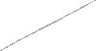Purpose: Used to provide information about services, campaign, project or goods. Software programs ‘Word’ or ‘Pages’ have a number of templates available to make it easy. Structure:
BROCHURE
- Title
- Introductory information about subject (Explanation)
- Sections of brochure divided into headings with specific aspects, characteristics or qualities
- Details of facts and figures outlined where relevant
- Persuasive language used to promote subject
- Layout is clear and well defined under section headings
- Contact details clearly outlined
- Catchy headings, phrases to stimulate interest
- Interesting eye-catching and colourful illustrations used as background Use language relevant to audience.
Short concise sentences and phrases.
Actioning verbs used and personal language to target appropriate audience.

Title

Explanation

Blocks of information under headings for specific aspects
  - Bullet points may be used
•
•
•
•
•

Details for prices/costs

Details for contact

Detailed Bibliography should be included.

Mount Lawley Senior High School


BROCHURE
Back Panel Heading
This is a good place to briefly, but effectively, summarise the products or services that you offer. Sales copy is typically not included here.
Front Cover
Large heading and graphic.
Contact details Phone: 555-555-5555
Fax: 555-555-5555
Email: xyz@microsoft. com
Organisation
Primary Business Address Your Address Line 2 Your Address Line 3 Your Address Line 4
Organisational logo, symbol and contact.

Inside Panel Heading
Most important information displayed here.
Introduce the subject, organisation or product.
Headings
Details of specific aspect.
Image
Headings
Headings
Use headings to describe specific aspects, characteristics or services.
Brief text boxes, illustrations and graphics to break up text.
Sub-headings
Make it easier to read.
Headings
Details of specific aspect.
Logo
Illustrations/graphic

Business details and contact information.

Mount Lawley Senior High School

